**Hospital Management Windows Software Testing Report**

**Smoke Testing**

The software is fully ready for further testing process. All module of software work properly.

**Black Box Testing**

**1. System Testing**

Log In

Log In functionality perform well, but when try to login with empty username and password value the pop up showing that “Username and Password do not match” It should be “Please give Username” or “Please give password” or both username and password or such like that.

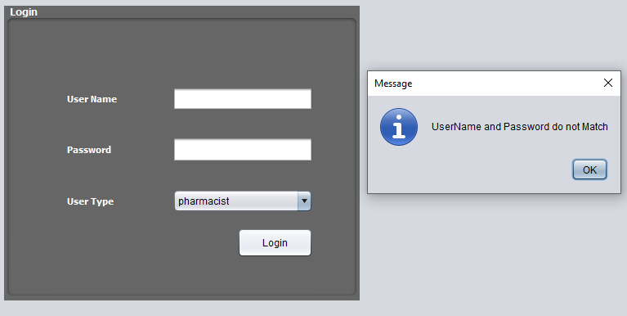

When try to log in with wrong username and password, the software is not showing specifically which field is not matched. It should be more specific.

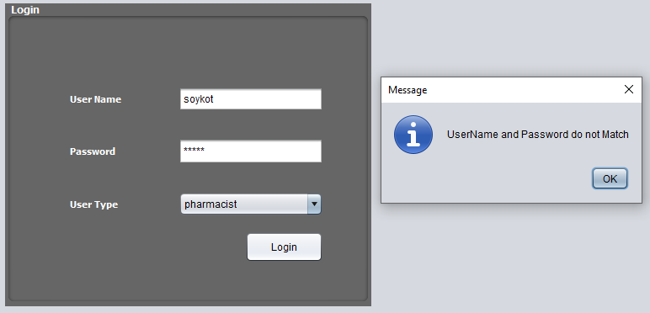

User Access

After login as a Pharmacist, Receptionist, Doctor, Admin all users can perform same task. It is matter of concern that Receptionists, Pharmacist, Doctor can able to create a user for this software. This function should be only available for admin of this software.

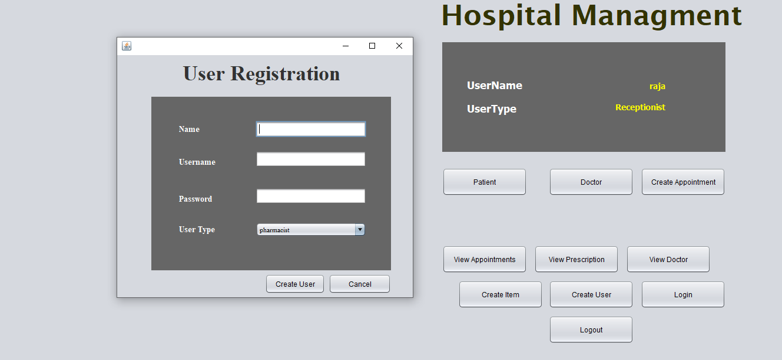

Create User

A user is created without giving name, username even a password.

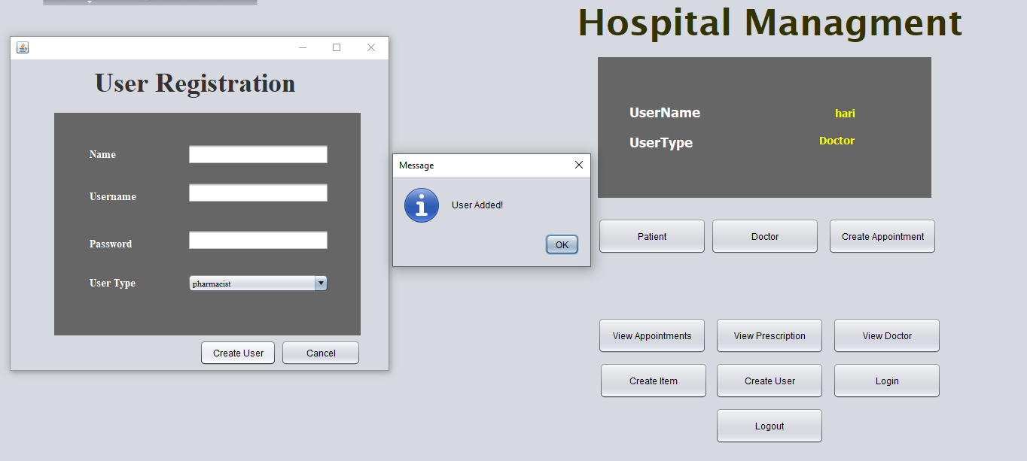

Other Functionality

Create Patient List, Doctor List, Create Appointment, View Appointment, View Prescription, View Doctor, create item are working well

**2. Performance Testing**

i . Load testing

It is able to take much load.

ii . Stress testing

It can handle more stress

Iii . Stability testing

It is less stable software

Iv . Scalability testing

The software is saleable

**3. Usability Testing**

In small screen mode, interface of the software is okay. But for full screen mode it is not good enough.

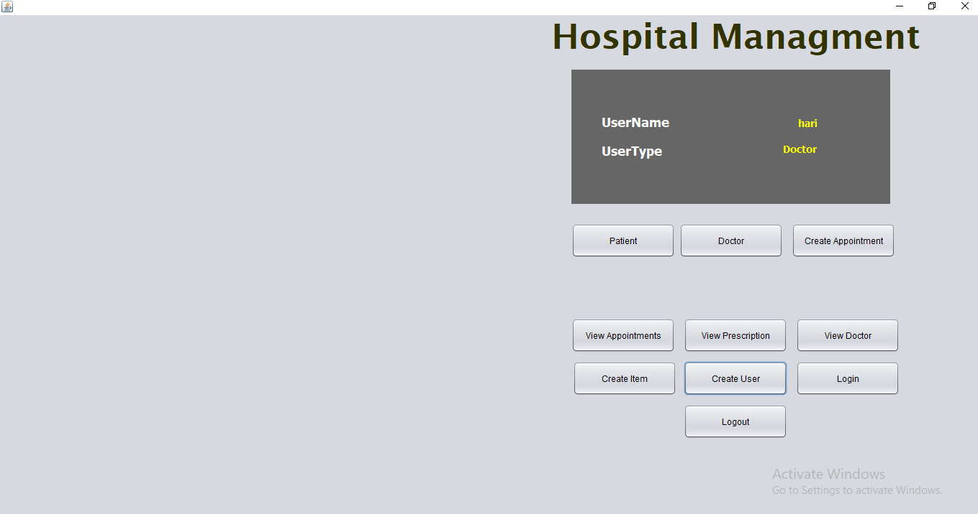

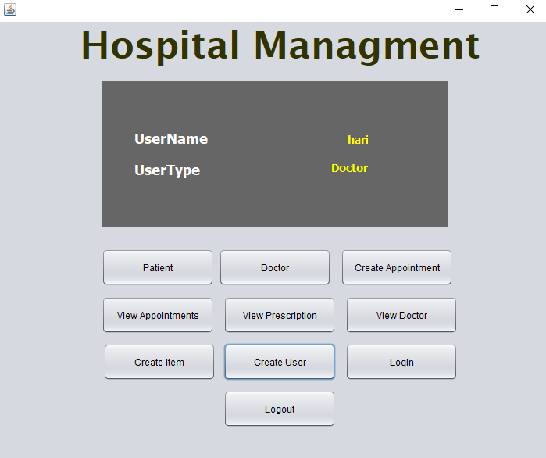

**4. Compatibility Test**

In various device it works well

**White Box Testing**

Log In System

It can be more user friendly. Password digit’s number can be shown in the interface of the software.

Other

All functionality is working well. Sometimes SQL Syntax Error is occurred.

**User Acceptance Testing**

Without some user interface issues almost all functionalities are performed well. That’s why it is acceptable by the end user.

**Security Testing**

This software less vulnerable by SQL Injection

**Alpha Testing**

All Interfaces is okay. There is a recommendation, In patient registration Screen patient data update is less user friendly for the first time use. A option should be kept for giving patient no. or it will be the best if there is a user guide for updating patient data.

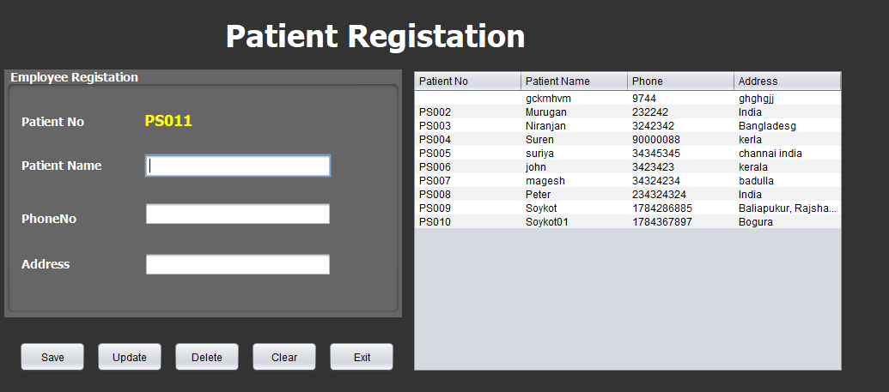

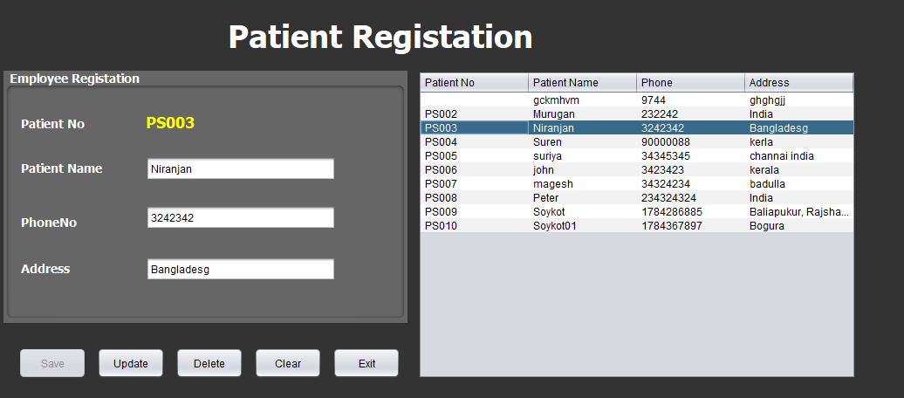

**Unit Testing**

Unit testing is performed when building the software for all functions. All functions are working as requirement.

Software Tester

Md. Soykot Hosen

CEO, Code Studio Software Company